Wild pitch

A wild pitch is one so high, so low or so wide of the plate that it cannot be handled with ordinary effort by the catcher [OBR Definition of Terms]
Example 45: The abbreviation used for a wild pitch is “WP” followed by the batting order number of the player who is on the plate at the time of the wild pitch.
The official scorer shall charge a pitcher with a wild pitch when a legally delivered ball is so high, so wide, or so low that the catcher does not stop and control the ball by ordinary effort, thereby permitting a runner or runners to advance.
WBSC |  | Traduction dans l’outil de scorage |  | Outil
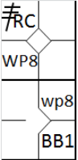 |  | /* Le premier batteur frappe un triple dans le champ droit */  action { batter -> 3BRC }  /* Le batteur suivant gagne la première base sur un 'base on ball' */  action { batter -> BB }  /* Le lanceur fait un lancer fou, les deux coureurs avance */  action { runner1 -> wp , runner3 -> WP } |  | 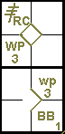
The official scorer shall charge a pitcher with a wild pitch when a legally delivered ball touches the ground or home plate before reaching the catcher and is not handled by the catcher, thereby permitting a runner or runners to advance [OBR 9.13(a)].
If more than one runner advances on a wild pitch, the abbreviation “WP” (upper case) is used for the lead runner, with “wp” (lower case) for the subsequent runners.
EXCEPTION: Example 46: In the event that the third strike is a wild pitch, permitting the batter to reach first base, the official scorer shall score a strikeout and a wild pitch [OBR 9.13(a)].
The abbreviation “WP” (upper case) along with a “K” for strikeout (followed, naturally, by the cumulative number of the strikeout for that pitcher) should be used for the batter.
The abbreviation “wp” (lower case) is used for any runners who advance.
WBSC |  | Traduction dans l’outil de scorage |  | Outil
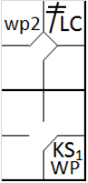 |  | /* Le premier batteur frappe un double dans le champ gauche */  action { batter -> 2BLC }  /* Sur le strike le batteur suivant swing et atteint la première base, le coureur avance */  action { batter -> KSWP , runner2 -> wp } |  | 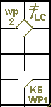

Example 47: If a runner advances more than one base on a wild pitch, an arrow is used to indicate the continued advance.
WBSC |  | Traduction dans l’outil de scorage |  | Outil
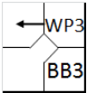 |  | /* Le batteur bagne la première base sur un 'base on ball' */  action { batter -> BB }  /* Le coureur profite d'un lancer fou pour gagner deux base */  action { runner1 -> WP+ } |  | 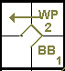

Example 48: If a runner advances more than one base on more than one wild pitch to the same batter, the abbreviation “WP” is used for each wild pitch.
WBSC |  | Traduction dans l’outil de scorage |  | Outil
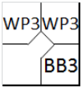 |  | /* Le batteur bagne la première base sur un 'base on ball' */  action { batter -> BB }  /* Le coureur profite d'un lancer fou pour gagner une base */  action { runner1 -> WP }  /* Le coureur profite d'un deuxième lancer fou pour gagner une base */  action { runner2 -> WP } |  | 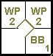
The official scorer shall not charge a wild pitch […] if the defensive team makes an out before any runners advance. For example, if a pitch touches the ground and eludes the catcher with a runner on first base, but the catcher recovers the ball and throws to second base in time to retire the runner, the official scorer shall not charge the pitcher with a wild pitch. The official scorer shall credit the advancement of any other runner on the play as a fielder’s choice. [OBR 9.13 Comment]

